Business Plan

www.supernanny.com



2008

*Supernanny.com S.A.*

*54, Puvis de Chavannes*

*92400 Courbevoie*

*Ph : 06987654*

Amanda Hartley. Nicola Jamieson. Maria Isabel Librero. Jose María Recio. Miguel Surname.

# Contents

Title Pages **Page No**

Title Page i

Contents 2

CHAPTER 1

1.0 Executive Summary

CHAPTER 2

2.0 Background

2.1 The Problem & Business Opportunity

2.2 Product or Service

2.2.2 The Unique Selling Points (USP)

2.3 Industry & Market Analysis

2.3.2 Competitor Analysis

2.4 Business Operation

2.5 Sales & Marketing Strategy

2.6 Management Team

2.7 Funding Requirements & Financial Plan

2.8 Key Issues & Risk Assessment

2.9 Action Plan & Milestones

CHAPTER 3 - APPENDICES

A Birth Rate in the European Union

B Percentage of Parents Working, Including Activity Rate and Position

C Births in Ile-de-France (Paris) from 2003 to 2007

D Median Disposable Income by Family Type

E The Elevated Salaries in the Districts of the West-Central Region

F Pricing Table

1.0 Executive Summary

Nanny Online, newly founded in 2008 is a childcare service which provides parents with a reliable source of childcare at a reasonable cost. Our service is built up from a team of five members experienced in all aspects of business, including marketing, finance, human resources, business law, and advertising. Our service is dedicated to providing high quality childcare services to those who need it. Our employees are the key to success therefore our nannies are required to undertake a number of rigorous interview processes prior to employment, and following recruitment they are expected to participate in training courses to ensure high levels of professionalism and standards of excellence. Nanny Online will enable children to grow and develop with the aid of our experienced nannies.

The principal activity of Nanny Online is to provide parents in France predominantly the Ile-de-France region, with a reliable source of childcare by supplying them with highly qualified, committed and competent nannies at a reasonable cost.

Over the years the need for childcare services has rapidly increased. Childcare services are principally needed by parents who work a lot, lone parent families where the parent must work and by parents who require some alone time. Nanny Online has recognised that in France a high number of women are returning to work after having a child, this in conjunction with in conjunction with the birth rate in France being the highest in the European Union, and the existing large number of lone parent families, has led to a substantial increase in the need for childcare services in the Île-de-France region of France. For this reason Nanny Online has recognised an opportunity to provide a reliable source of childcare to parents with relative ease and at a reasonable cost.

Our core objective is to be the number one website for providing childcare services however its short term objective is to build itself a reputation as a reliable and valuable source of childcare. In the long term, Nanny Online is looking to increase its annual market share in order to reach out to a broader market, stretching its services to other areas of France.

Nanny Online aims to develop a website which enables parents to access childcare services 24 hours a day. Our primary unique selling point (USP) will be that the service will be completely online, eliminating the usual time scale needed in the search for childcare. However another USP to draw attention to is our additional services. Nanny Online will offer parents an opportunity to broaden their child’s horizons with the option of additional extras including language, music, or cooking lessons as well as educational tutoring.

Nanny Online has identified its major competitors as: merciplus.fr, apreslaclasse.fr and kamy-nanny.fr. However, Nanny Online disregard these as a serious threat due to our unique selling points significantly differentiating us from them. Nanny Online also aims to eliminate the dangers of the Black Market by promoting its services in a positive manner.

Nanny Online has recognised its target market as lone parent families, parents who work a lot as well as parents who just need alone time. For this reason, our marketing campaign relies heavily upon advertising in areas with high family traffic levels. We intend to promote our company in a number of newspapers, family magazines in conjunction with distributing leaflets in schools and displaying billboards in family areas.

Nanny Online has identified its key internal alongside external issues and will adopt a responsive approach in order to eliminate these from becoming potential threats in the future.

In order to achieve success in our venture, we intend to implement a business model focusing on core strategy, strategic resources and partnership networks in conjunction with the crucial element, customer interface.

2.0 Background

Basic Company Information

Nanny Online, newly founded in 2008, bases its services in and around the Paris area, predominantly the Ile-de-France region. Its principal activity is to provide parents in these areas with access to an easy and reliable method of childcare.

Mission Statement

The mission of Nanny Online is to provide high quality childcare within the Ile-de-France and Paris regions. Our service is dedicated to providing parents with highly qualified, committed, and reliable nannies in a way which is less time consuming and easy but also at a relatively low cost. Nanny Online will offer only standards of excellence, enabling children to grow and develop with the aid of our experienced nannies.

**The Purpose:** Dedicated to providing high quality childcare, 24 hours a day at relative ease.

**The Business:**  Providing parents with a reliable source of childcare by supplying them with qualified and committed nannies at a relatively low cost.

**The Values:** Individuals who are confident, committed and competent in conjunction with standards of excellence.

Business Objectives

**Short term:** To build a reputation as a reliable and valuable source of childcare.

**Medium term:** To become the number one website offering childcare services.

**Long term:** To increase annual market share and reach out to a broader market.

# 2.1 The Problem and Business Opportunity

Problem

As the number of women returning to work after having a child is on the increase in Europe, the need for childcare also rises alongside this. With one in every four families being single parent families, the birth rate being the highest of anywhere in the European Union, and more parents finding themselves without any other choice but to work to keep their families’ financial state afloat, France takes on the need for additional childcare to a greater extent than that of most European countries.

Opportunity

As problems within any population surface, so do opportunities for new ideas to be created in a bid to potentially resolve them. With the ratio of supply and demand for nannies showing that supply cannot currently keep up with demand, and perhaps parents finding the task of spending time searching for a nanny too difficult, the opportunity to provide easily accessible, reliable childcare to parents who now need it more than ever emerges.

How we aim to do this

The aim of this business venture is to design and create a website which will allow parents access to childcare easily, 24 hours a day. All nannies will be subject to rigorous interviews by the selected management team members to assess credibility and assiduousness, and will then be required to undergo and complete comprehensive training to ensure a high standard of professionalism, before having their information placed on the website.

The website itself will be designed to look sleek and professional, while simultaneously being easy to access and use as well as a quick solution to any parents childcare needs - maintaining the comprehensibility the business prides and bases itself upon.

# 2.2 Product or Service

In recent years there has been a significant increase in the number of women working. This in conjunction with the birth rate in France being the highest in the European Union, and the existing large number of lone parent families whose parents work, has led to a substantial increase in the need for childcare services in the Île-de-France region of France. For this reason Nanny Online has recognized an opportunity to provide a reliable source of childcare to parents with relative ease and at a relatively low cost.

Nanny Online aims to design and create a website which enables parents to access childcare 24 hours a day. Parents will use a search engine in order to select their most suitable client, before reserving them there and there. There will no need to await a phone call as the service is completely exclusively online. This will save parents time and money when trying to find an appropriate childcare service.

In order to guarantee the best possible service selected experienced members of our management team will carry out a rigorous interview process in which nannies will be subject to a number of tests including practical and personality tests. Preceding recruitment, nannies will be required to undergo and complete a two day training course in order to ensure a high standard of professionalism, before their information is released on the company website. Regular checks will be carried out during the duration of the nannies contract to maintain this high standard.

The website itself will be designed to look sleek and professional, while simultaneously being quick and easy to access and use - maintaining the comprehensibility the business prides and bases itself upon.

# 2.2.2 The Unique Selling Points (USP)

Nanny Online provides a number of unique selling points (USP) to its consumers and its employees. The most USP which Nanny Online possesses is a complete online service, available 24 hours a day. This means parents have the ability to reserve a nanny whenever they require. Unlike its competitors, Nanny Online will provide a direct service. This will reduce the delay normally caused by awaiting a response from an agency.

Parents will also have the opportunity to add extras for a small additional excess fee at a rate of €4 per hour. These services include language lessons, music lessons, cooking lessons or educational tutoring.

Nanny Online is a certified service which is dedicated to providing parents with the best possible childcare. Nannies will be required to undergo a rigorous interview process with a number of practical and personality tests. Following recruitment nannies will be required to undergo a two day training program, and once their information is released on the website regular check ups will be carried out to ensure the highest standards of professionalism.

In such a questionable line of work, it is often difficult to guarantee a regular income. Therefore, at Nanny Online we aim to provide our nannies with a contract guaranteeing them a certain number of hours, at a fixed rate of pay.

# 2.3 Industry & Market Analysis

Child care is principally needed by couples who both work, by lone parent families where the father/mother works, or by parents who want leisure time without their children. In addition to this the integration of women into the work place has rapidly increased leading to childcare needs increasing significantly alongside.

According to research France has the highest birth rate in the European Union (see **Appendix A**). This indicates that France is potentially the most suitable in the EU to set up a childcare service, due to the high impending market. More research form INSEE indicates that 85.0% of women and 95.8% of men who are in couple and have two children aged 3 or more are engaged in labour (See **Appendix B**).This is a significant indication of how attractive the market as it clearly defines that with so many parents engaged in labour the need for childcare services is essential.

Paris has a total population of 6.579.229[1] aged 20 to 59 and there are approximately 30 000 children born each year in this city (see **Appendix C**). This is a key assurance of a growth in the market year after year.

In addition, a major trend to state is the augmentation in lone parent families within France. In Paris, one in every four families is of this type. Over a period of thirty years this number has increased by 26% and involves around 93 000 children. Of this total 12% of these children were under 3 years old. Lone parent families also tend to possess the characteristic of being more qualified, having followed further higher education. Of these 52% of lone parent women with more than one child works full time and this ascends to 79.4% in the case of men. (Also indicated in **Appendix B**)

In order to assess the ability of parents to afford childcare services it is also important to evaluate the disposable income of parents on an annual basis (see **Appendix D**). Appendix 4 clearly states that the more children a couple have, the higher their annual disposable income will be. For this reason, it would be beneficial to target parents in areas with a high disposable income. This is a good indication of how liable parents will be to purchase childcare services with regards to their ability to afford it. In order to further evaluate this, a map of Paris representing the differences in average hourly revenue of the population has also been added in the appendices (see **Appendix E**). Appendix 5 indicates that the areas of Paris with a high disposable income are: 8eme arrondisement, Puteaux, Neuilly sur Seine, Levallois, Saint-Claude and Issy-les Moulineax. Therefore, this information highlights that these areas are the most potential areas for business.

# 2.3.2 Competitor Analysis

**Direct competitors**

Nanny Online will adopt similar pricing strategy levels as its competitors however prices will be dependant upon the amount of hours our nannies will be required to serve. Another element which affects the pricing will be the period of notice given by the parent in advance of the due arrival. However, Nanny Online will differentiate itself by offering further services at an additional few of as little as €4 per hour. These will include activities such as language lessons, music lessons, cooking lessons or tutoring in areas of schoolwork. In addition parents will be able to directly reserve a nanny online any time of the day, without having to search through numerous Curriculum Vitae’s and await a response.

We also have to evaluate our **Indirect Competitors** which can be categorised into two groups, the Black Market and Internet Search Sites.

* Black Market: This is a system which offers childcare at the reduced average rate of €9 per hour, but does not include the 50% governmental tax return. This market has been very popular, but due to a growing problem in the satisfaction of their nanny services, parents have moved towards a more controlled business model.
* Internet Search Sites: The parents will search for nannies on the internet, through websites which contain numerous CV’s. The parents must then read through the available offers, contact a numerous variety of nannies and then interview them. This system is therefore very time consuming, and is a much less efficient model. There are numerous examples of websites which use this kind of model, including:
  + <http://www.notre-nounou.com/>
  + <http://www.manounou.com/>
  + <http://www.gardes-enfants.com/>

# 2.4 Business Model

# 2.5 Sales & Marketing Strategy

Overall approach to the target market

Different target markets:

* Parents who work a lot / Lone Parent Families : Regular nanny services
* Parents who work until late: After school pick-up nanny
* Parents who want to go out: Night services
* Emergency: Express nanny services

Our regular services and after school pick-ups will also offer additional services. These are listed under the Pricing Strategy of the marketing mix below. **Note:** These services will not be available on short notice.

Marketing mix

* Product Strategy

Our service is based on a website which provides a certified service in which parents can use online reservation for nannies. We know that our customers will have different needs so we will adapt our services according to these. Our website will have the domain [www.nannyonline.fr](http://www.nannyonline.fr) which clearly defines our product and is readily available. On this webpage parents would be able to see the different nannies we have, their availability and characteristics. The advantage of this website is that parents can reserve their chosen nanny online. We offer a certified service which means that our nannies are hired having passed different quality control tests and having previously completed a training course in childcare.

* Channels of Distribution

Our customers will be obliged to register as a member on our website the first time they visit. Once registered, they will be required to sign-in on each future visit. When signed-in, our clients will have access to the wide availability of our nannies and will use a search engine menu in order to choose the necessary characteristics they require in their nanny. Through the use of the internet our clients will be able to reserve the nanny of their choice for the hours they require. A 10% reservation fee will be charged in advance.

The details of the reservations will then enter our system and the nanny would be contacted by a member of our team. The nanny will call the parent(s) one day before the required service is due (in the case of an express service it will be a few hours beforehand) in order to confirm. The nanny will then go to the customer’s house for the required hours. The parents will be required to sign the service as satisfactory before making the full payment for the service. If our clients aren’t satisfied they shouldn’t sign this paper and a member of the team will then contact them within 24 hours of the service taking place, in order to discuss the problem encountered during the service period. Our personnel would then be required to offer additional services in order to compensate for the problem, or reimburse the client.

*Should any issues arise on the internet, or parents have any questions they can use the contact number in order to contact our management team. It will also be possible to arrange a service over the phone for those parents who feel it a more comfortable method.

* Promotion

Our first promotion plan is to situate our website as the first result on Google when a search for “nanny, nounou, babysitter, or child care in France” is typed into the search engine.

However our lower scale strategy is to hand out leaflets in local schools for children to give to their parents. This will be conducted particularly in areas where parents work long hours and have a higher income and also in areas where the birth rate is high, for example Courbevoie or Nanterre. In addition to this another promotional activity would be billboards printed with a picture of a baby pram and our logo concentrating particularly on school and play park areas. Handing out flyers around these areas would also be beneficial to promoting the company.

Prior to the launch of our website we will advertise our service in several newspapers including; Le Monde, Le Figaro and Le Parisien as well as family magazines such as Famili, in order to make our service known to the market.

A possibility for the future is to feature a small documentary explaining the lack of nannies found in and around the Paris area of France. It would also be beneficial for us to outline the dangers of the black market indicate the most suitable solution to this social problem would be to use our website. This is may be costly, but it is very effective and reaches out to a wide audience.

Also, as parents’ sign in to our website we get to know them better as they choose the different characteristics of the nannies. We could address these parents by direct mail with different offers and new services we include into our website.

An additional extra in our promotion strategy will be to provide our customers with fridge magnets the first time they use our service. This promotional tool is accomplished at a low cost but provides our customers with a constant reminder of our high quality service should they require a service urgently.

* Pricing Strategy

Having researched a number of competitors in our market, we have decided to use a similar pricing strategy. We have decided to take the median price of our market competitors and price ourselves slightly above this, but maintaining a reasonable cost.

Our nannies will have to undertake training courses prior to release and due to our certified-high quality approach our prices do need to be slightly different. But, as the Baraboo law will return 50% of the cost for the service of our nannies to our customers at the end of the year, the actual price parents will pay is much lower than advertised. This is a positive outcome for both parties as parents and the company will benefit from this. Parents will recover 50% of their fees from the government, and our company will receive the full advertised price.

Another element which has to be considered is the additional services which our company will offer to its clients. Additional services which can be requested by parents include language lessons, music lessons, cooking lessons, and tutoring. For this reason our pricing strategy will differ slightly due to a small additional fee in order to cover these extra services. An example of the price list can be found in the Appendices. (See **Appendix F**)

Extra: <http://www.caf.fr/cataloguepaje/GardPajeStructure.htm#conditions>: This website provides information about the conditions regarding government aid concerning funding.

2.6 Management Team2.8 Key Issues and Risk Assessment

Below are 10 potential risks which could pose a threat to our company:

|  |  |  |
| --- | --- | --- |
| **Type** | **Subtype** | **Risk** |
| Business Environment | Customers | Customers are unaware of our company which may lead to ignorance and distrust. |
| Parents requiring childcare services may already have a regular nanny and therefore may ignore us as a possibility. |
| Employees (Nannies) | Management team needs to find qualified, experienced and reliable nannies. |
| Nannies will gain communication with our clientele, and may breach their contract by providing parents with their details themselves leading to private communication |
| Due to Nanny Online relying heavily upon its nannies to maintain its service, the loss of its employees would be a potential risk. |
| Market | Competition exists in a variety of forms within the childcare services market. Nanny Online needs to be aware of their competition in order to stay ahead of them. |
| Operations | Marketing & sales | Our advertising message may not reach our target market. Our service cares for children, but parents are who we need to target as they require the service. We should advertise on the Internet, in magazines for mothers, and local newspapers ... |
| Legal | It can be difficult to ensure that all legal formalities are not breached. Nannies will gain communication with our clientele, and may breach their contract by providing parents with their personal details leading to private communication, and a possible lawsuit. |
| Technology | The Net | If there are any problems with the website, we might lose potential or existing customers. |
| Management | Strategy & implementation | We must plan our strategy well, so we can meet the proposed objectives. |

2.9 Action Plan & MilestonesAppendices

Appendix A **– Birth Rate in the European Union**

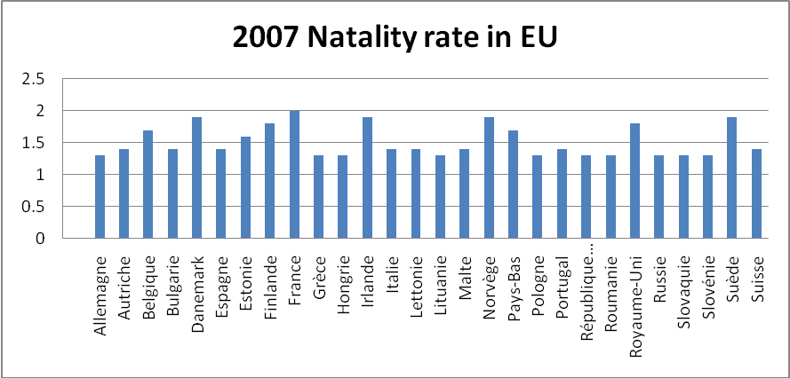

Source: Proper elaboration from data found in [www.inee.fr](http://www.inee.fr); Population Reference Bureau

Appendix B **– Percentage of Parents Working, Including Activity Rate and Position.**

|  |  |  |  |  |  |  |  |  |
| --- | --- | --- | --- | --- | --- | --- | --- | --- |
|  | **Activity rate (%)** | | **Where:** | | | | | |
|  | **full time** | | **part time** | | **unemployed** | |
|  | **women** | **men** | **women** | **men** | **women** | **men** | **women** | **men** |
| **In couple** | **77,4** | **91,8** | **48,7** | **84,5** | **23,3** | **3,1** | **5,4** | **4,2** |
| without children | 76,7 | 84,9 | 53,3 | 76,6 | 17,9 | 3,8 | 5,5 | 4,5 |
| 1 child smaller than 3 years of age | 80,6 | 97,7 | 53,6 | 88,0 | 19,1 | 3,9 | 7,9 | 5,7 |
| 2 children, 1 of them smaller than 3 | 61,3 | 96,8 | 31,7 | 88,5 | 25,1 | 3,3 | 4,5 | 5,0 |
| 3 children or more, 2 of them smaller than 3 | 39,0 | 96,6 | 17,3 | 87,7 | 19,1 | 3,7 | 2,6 | 5,2 |
| 1 child aged 3 or more | 82,3 | 92,3 | 54,5 | 85,8 | 22,6 | 2,7 | 5,2 | 3,7 |
| 2 children aged 3 or more | 85,0 | 95,8 | 50,7 | 90,7 | 29,9 | 2,1 | 4,4 | 3,0 |
| 3 children aged 3 or more | 70,3 | 95,0 | 33,1 | 86,6 | 30,2 | 3,3 | 7,0 | 5,1 |
| **Not in couple** | **79,8** | **83,6** | **56,2** | **69,9** | **15,8** | **5,2** | **7,8** | **8,5** |
| without children | 78,3 | 82,8 | 58,9 | 69,0 | 13,7 | 5,3 | 5,8 | 8,5 |
| 1 child or more | 82,0 | 91,4 | 52,3 | 79,4 | 19,0 | 4,1 | 10,7 | 8,0 |
| **Total** | **78,0** | **89,9** | **50,6** | **81,1** | **21,4** | **3,6** | **6,0** | **5,2** |
| Note: median results for the year. This corresponds to metropolitan France of people aged 15 to 59 | | | | | | | |  |
|  |  |  |  |  |  |  |  |  |
| Source : Insee, enquêtes Emploi du 1er au 4ème trimestre 2007. | | | |  |  |  |  |  |

Appendix C **- Births in Ile-de-France (Paris) from 2003 to 2007**

|  |  |  |  |  |  |
| --- | --- | --- | --- | --- | --- |
|  | **2003** | **2004** | **2005** | **2006** | **2007** |
| Paris 1er Arrondissement | 189 | 231 | 220 | 236 | 185 |
| Paris 2e Arrondissement | 346 | 370 | 359 | 324 | 320 |
| Paris 3e Arrondissement | 496 | 490 | 503 | 453 | 505 |
| Paris 4e Arrondissement | 340 | 309 | 318 | 309 | 323 |
| Paris 5e Arrondissement | 592 | 559 | 578 | 608 | 558 |
| Paris 6e Arrondissement | 401 | 445 | 437 | 396 | 382 |
| Paris 7e Arrondissement | 626 | 621 | 579 | 582 | 548 |
| Paris 8e Arrondissement | 600 | 537 | 513 | 567 | 514 |
| Paris 9e Arrondissement | 888 | 930 | 905 | 979 | 925 |
| Paris 10e Arrondissement | 1574 | 1578 | 1660 | 1672 | 1628 |
| Paris 11e Arrondissement | 2237 | 2268 | 2271 | 2288 | 2242 |
| Paris 12e Arrondissement | 1837 | 1960 | 1876 | 1951 | 1911 |
| Paris 13e Arrondissement | 2213 | 2215 | 2117 | 2192 | 2237 |
| Paris 14e Arrondissement | 1703 | 1664 | 1721 | 1661 | 1627 |
| Paris 15e Arrondissement | 3160 | 3183 | 3079 | 3138 | 2964 |
| Paris 16e Arrondissement | 1953 | 1985 | 1888 | 1888 | 1869 |
| Paris 17e Arrondissement | 2479 | 2559 | 2400 | 2496 | 2431 |
| Paris 18e Arrondissement | 3428 | 3513 | 3534 | 3534 | 3366 |
| Paris 19e Arrondissement | 3380 | 3368 | 3351 | 3269 | 3264 |
| Paris 20e Arrondissement | 3051 | 3032 | 3069 | 3205 | 3021 |
| Paris (TOTAL) | 31493 | 31817 | 31378 | 31748 | 30820 |

Source: INSEE: État civil

Appendix D **– Median Disposable Income by Family Type**

Source : Proper elaboration from data found in Insee [www.insee.fr](http://www.insee.fr), « Insee, enquêtes Emploi du 1er au 4ème trimestre 2007 »

Appendix E **– The Elevated Salaries in the Districts of the West-Central Region**

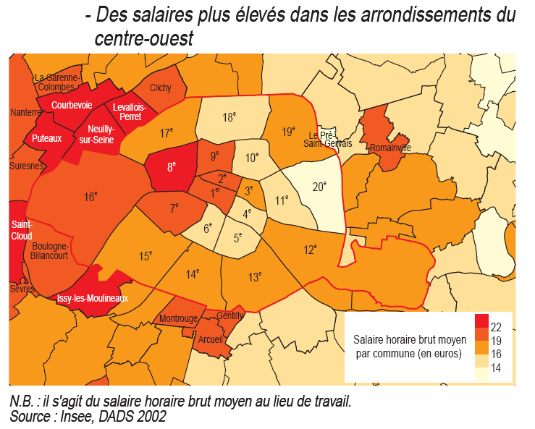

Appendix F **– Pricing Table**

|  |  |  |  |  |  |  |
| --- | --- | --- | --- | --- | --- | --- |
| Pricing Index for Nanny Service | | | | | | |
|  |  |  |  |  |  |  |
|  | **Price per Rate Option (in Euros)** | | | | | |
| **Rate Options** | Contracted | Price with Tax Rebate | Special Requests | Price with Tax Rebate | Urgent | Price with Tax Rebate |
| Regular Rate/Hour | 19 | 9.5 | 25 | 12.5 | 22 | 11 |
| Up to 8 Hours | 18 | 9 | 24 | 12 | N/A | N/A |
| Up to 24 Hours | 17 | 8.5 | 24 | 12 | N/A | N/A |
| Weekly Rate (max 8 hours) | 650 | 325 | 800 | 400 | 750 | 375 |
| Daily Flat Rate (For Ongoing Service) | 550 | 275 | 760 | 380 | N/A | N/A |
| Weekend Rate/Hour | 20 | 10 | 28 | 14 | 25 | 12.5 |
| Weekend Flat Rate | 600 | 300 | 800 | 400 | 700 | 350 |

**\*Prices may be subject to change**

1. Source: Insee. Estimations of population from 1st January